Lung Cancer CT Scan Classification - Analysis Report

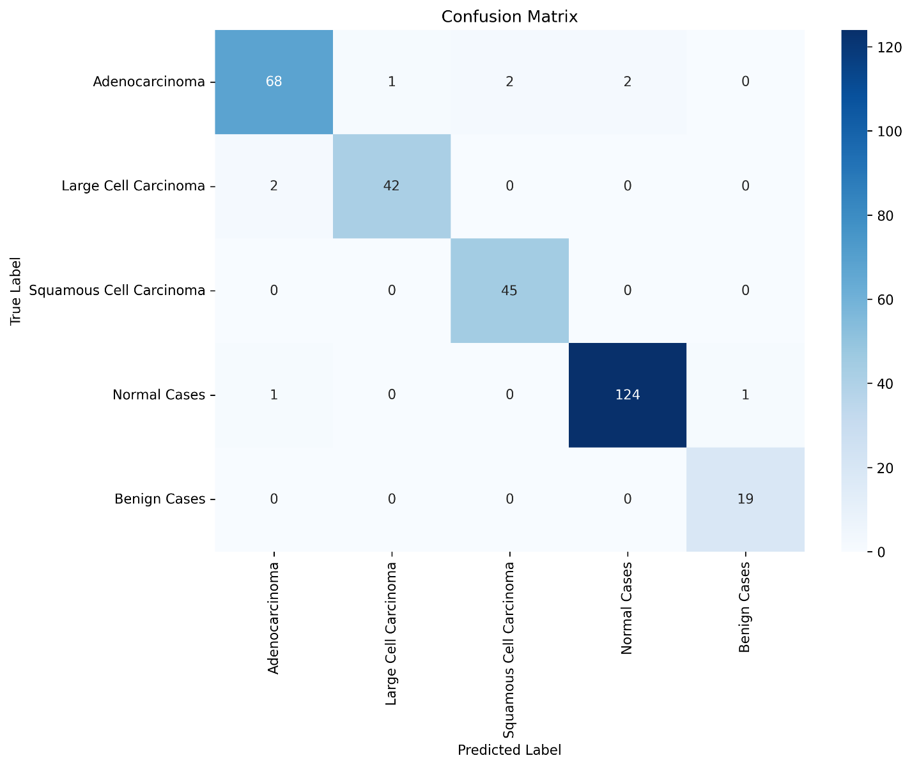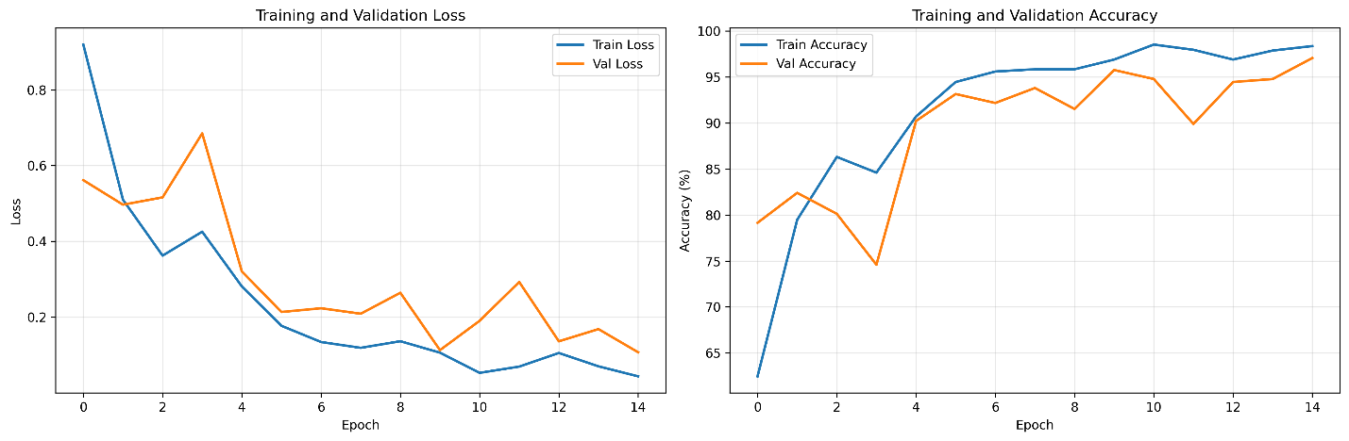

Introduction
This project implements a deep learning classifier to detect and classify lung cancer types from CT scan images. The model identifies five categories: Adenocarcinoma, Large Cell Carcinoma, Squamous Cell Carcinoma, Normal Cases, and Benign Cases.

Dataset: 1,535 CT scan images from Kaggle
- Adenocarcinoma: 337 images
- Large Cell Carcinoma: 187 images
- Squamous Cell Carcinoma: 260 images
- Normal Cases: 631 images
- Benign Cases: 120 images

Methodology

Model Architecture
- Backbone: ResNet18 with transfer learning
- Input Size: 128x128 RGB images
-Classifier: Custom layers with dropout
- Output: 5 classes (softmax)

Training Configuration
- Epochs: 15
- Batch Size: 16
- Optimizer: Adam (lr=0.001)
- Loss: Cross Entropy
- Split: 80% training, 20% validation

Results

Performance Metrics
- Final Validation Accuracy: 97.07%
- Final Training Accuracy: 98.21%
- Macro F1-Score: 99.03%

Confusion Matrix Analysis
![Confusion Matrix](confusion_matrix.png)

The model shows excellent performance across all classes with minimal misclassifications. Most confusions occur between Normal and Benign cases.

Training Progress
![Training History](training_history.png)

The training shows stable convergence with both training and validation accuracy improving consistently. No significant overfitting observed.

